**COFFEE SHOP SALES ANALYSIS**

* **CREATE DATABASE**

Create database if not exists coffee_sales;

* **SEEING TABLES**

select * from coffeesales;

* **CONVERT DATE (transaction_date) COLUMN TO PROPER DATE FORMAT**

update coffeesales

set transaction_date = STR_TO_DATE(transaction_date, '%d-%m-%Y');

* **ALTER DATE (transaction_date) COLUMN TO DATE DATA TYPE**

alter TABLE coffeesales

modify COLUMN transaction_date DATE;

* **CONVERT TIME (transaction_time) COLUMN TO PROPER DATE FORMAT**

update coffeesales

set transaction_time = str_to_date(transaction_time , '%H:%i:%s');

* **ALTER TIME (transaction_time) COLUMN TO DATE DATA TYPE**

alter table coffeesales

modify column transaction_time time;

* **DATA TYPES OF DIFFERENT COLUMNS**

desc coffeesales;

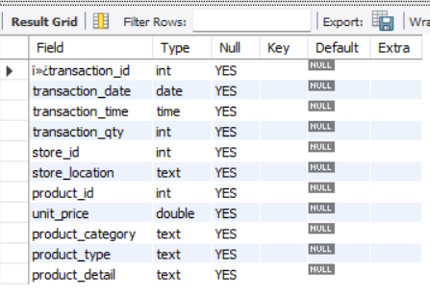

* **CHANGE COLUMN NAME `ï»¿transaction_id` to transaction_id**

alter table coffeesales

change column ï»¿transaction_id transaction_id int;

* **TOTAL SALES Analysis**

select round(sum(unit_price * transaction_qty)) as Total_Sales

from coffeesales

where

month(transaction_date) = 5;

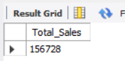

* **TOTAL SALES KPI - MOM DIFFERENCE AND MOM GROWTH**

SELECT

MONTH(transaction_date) AS month,

ROUND(SUM(unit_price * transaction_qty)) AS total_sales,

(SUM(unit_price * transaction_qty) - LAG(SUM(unit_price * transaction_qty), 1)

OVER (ORDER BY MONTH(transaction_date))) / LAG(SUM(unit_price * transaction_qty), 1)

OVER (ORDER BY MONTH(transaction_date)) * 100 AS mom_increase_percentage

FROM coffeesales

WHERE

MONTH(transaction_date) IN (4, 5) -- for months of April and May

GROUP BY

MONTH(transaction_date)

ORDER BY

MONTH(transaction_date);

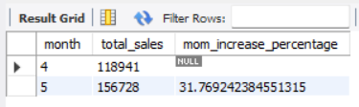

* **Total Orders Analysis**

select count(transaction_id) as Total_Orders

from coffeesales

where month(transaction_date) = 5;

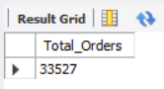

* **TOTAL ORDERS KPI - MOM DIFFERENCE AND MOM GROWTH**

SELECT

MONTH(transaction_date) AS month,

ROUND(count(transaction_id)) AS total_orders,

(count(transaction_id) - LAG(count(transaction_id), 1)

OVER (ORDER BY MONTH(transaction_date))) / LAG(count(transaction_id), 1)

OVER (ORDER BY MONTH(transaction_date)) * 100 AS mom_increase_percentage

FROM

coffeesales

WHERE

MONTH(transaction_date) IN (4, 5) -- for months of April and May

GROUP BY

MONTH(transaction_date)

ORDER BY

MONTH(transaction_date);

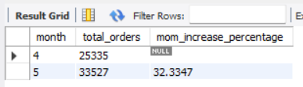

* **Total Quantity sold**

select sum(transaction_qty) as Total_Quantity_Sold

from coffeesales

where month(transaction_date) = 5;

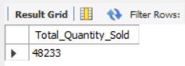

* **TOTAL QUANTITY SOLD KPI - MOM DIFFERENCE AND MOM GROWTH**

SELECT

MONTH(transaction_date) AS month,

ROUND(SUM(transaction_qty)) AS total_quantity,

(SUM(transaction_qty) - LAG(SUM(transaction_qty), 1)

OVER (ORDER BY MONTH(transaction_date))) / LAG(SUM(transaction_qty), 1)

OVER (ORDER BY MONTH(transaction_date)) * 100 AS mom_increase_percentage

FROM

coffeesales

WHERE

MONTH(transaction_date) IN (4, 5) -- for months of April and May

GROUP BY

MONTH(transaction_date)

ORDER BY

MONTH(transaction_date);

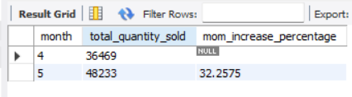

* **CALENDAR TABLE – DAILY SALES, QUANTITY and TOTAL ORDERS**

SELECT

SUM(unit_price * transaction_qty) AS total_sales,

SUM(transaction_qty) AS total_quantity_sold,

COUNT(transaction_id) AS total_orders

from coffeesales

where transaction_date = "2023-05-18";

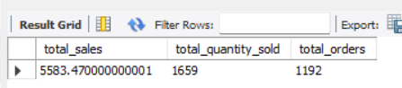

* **SALES BY WEEKDAY / WEEKEND:**

select

case when dayofweek(transaction_date) in (1,7) then "WeekEnds"

else "WeekDays"

end as day_type,

round(sum(unit_price * transaction_qty),2)as total_sales

from coffeesales

where month(transaction_date) = 5

group by day_type;

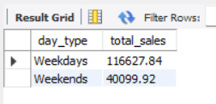

* **SALES BY STORE LOCATION**

select , store_location ,

concat(round(sum(unit_price * transaction_qty)/1000 , 1),"k") as Total_sales

from coffeesales

where month(transaction_date) = 5

group by store_location

order by Total_sales desc;

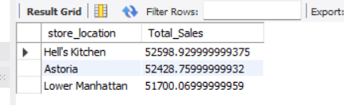

* **SALES TREND OVER PERIOD**

SELECT concat(round(AVG(Total_Sales)/1000,1),"k") AS average_sales

FROM (

SELECT

SUM(unit_price * transaction_qty) AS Total_Sales

FROM

coffeesales

WHERE

MONTH(transaction_date) = 5 -- Filter for May

GROUP BY

transaction_date

) AS internal_query;

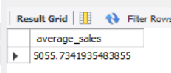

* **DAILY SALES FOR MONTH SELECTED**

SELECT

DAY(transaction_date) AS day_of_month,

ROUND(SUM(unit_price * transaction_qty),1) AS total_sales

FROM

coffeesales

WHERE

MONTH(transaction_date) = 5 -- Filter for May

GROUP BY

day_of_month

ORDER BY

day_of_month;

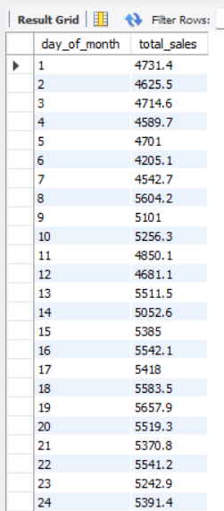 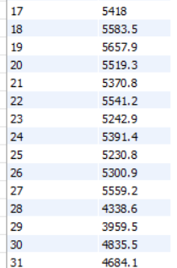

* ***COMPARING DAILY SALES WITH AVERAGE SALES – IF GREATER THAN “ABOVE AVERAGE” and LESSER THAN “BELOW AVERAGE***

SELECT

day_of_month,

CASE

WHEN total_sales > avg_sales THEN 'Above Average'

WHEN total_sales < avg_sales THEN 'Below Average'

ELSE 'Average'

END AS sales_status,

total_sales

FROM (

SELECT

DAY(transaction_date) AS day_of_month,

SUM(unit_price * transaction_qty) AS total_sales,

AVG(SUM(unit_price * transaction_qty)) OVER () AS avg_sales

FROM

coffeesales

WHERE

MONTH(transaction_date) = 5 -- Filter for May

GROUP BY

DAY(transaction_date)

) AS sales_data

ORDER BY

day_of_month;

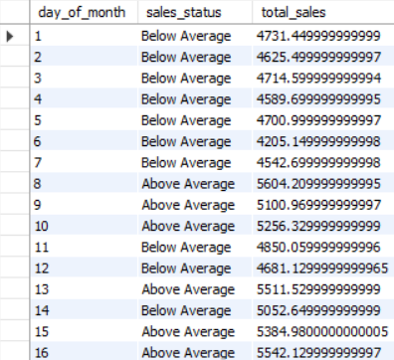 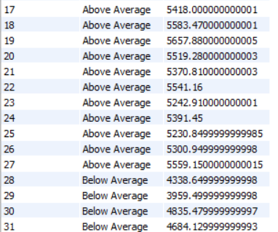

* **SALES BY PRODUCT CATEGORY**

SELECT

product_category,

ROUND(SUM(unit_price * transaction_qty),1) as Total_Sales

FROM coffeesales

WHERE

MONTH(transaction_date) = 5

GROUP BY product_category

ORDER BY SUM(unit_price * transaction_qty) DESC;

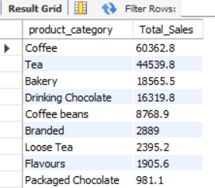

* **SALES BY PRODUCTS (TOP 10)**

SELECT

product_type,

ROUND(SUM(unit_price * transaction_qty),1) as Total_Sales

FROM coffeesales

WHERE

MONTH(transaction_date) = 5

GROUP BY product_type

ORDER BY Total_Sales DESC

LIMIT 10;

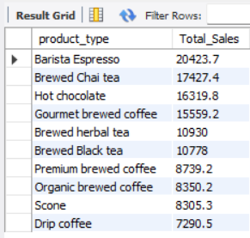

* ***TO GET SALES FOR ALL HOURS FOR MONTH OF MAY***

SELECT

HOUR(transaction_time) AS Hour_of_Day,

ROUND(SUM(unit_price * transaction_qty)) AS Total_Sales

FROM

coffeesales

WHERE

MONTH(transaction_date) = 5 -- Filter for May (month number 5)

GROUP BY

HOUR(transaction_time)

ORDER BY HOUR(transaction_time);

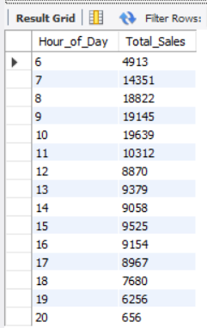

* ***TO GET SALES FROM MONDAY TO SUNDAY FOR MONTH OF MAY***

SELECT

CASE

WHEN DAYOFWEEK(transaction_date) = 2 THEN 'Monday'

WHEN DAYOFWEEK(transaction_date) = 3 THEN 'Tuesday'

WHEN DAYOFWEEK(transaction_date) = 4 THEN 'Wednesday'

WHEN DAYOFWEEK(transaction_date) = 5 THEN 'Thursday'

WHEN DAYOFWEEK(transaction_date) = 6 THEN 'Friday'

WHEN DAYOFWEEK(transaction_date) = 7 THEN 'Saturday'

ELSE 'Sunday'

END AS Day_of_Week,

ROUND(SUM(unit_price * transaction_qty)) AS Total_Sales

FROM coffeesales

WHERE

MONTH(transaction_date) = 5 -- Filter for May (month number 5)

GROUP BY Day_of_Week;

